# **Case Study 2: Order and Return Analysis Report**

## **Executive Summary**

This report analyzes order and return data to provide insights into sales performance, return rates, and customer behavior for Kultra Mega Stores (KMS). Using data from order details and return statuses, we identified key trends in product categories, customer segments, and geographic regions.

## **1. Introduction**

This report presents an analysis of order and return data to support strategic decision-making. The objectives are to:

* Quantify the impact of returned orders on sales and profit.
* Identify patterns in returns by product category, customer segment, and geographic region.
* Provide recommendations to improve operational efficiency and customer satisfaction.

The analysis is based on two datasets:

* **Order Details**: Contains detailed order information, including sales, profit, product categories, customer segments, and shipping details.
* **Order Status**: Lists orders with a "Returned" status.

## **2. Data Overview**

The datasets include:

* **Order_Status.csv**: Records of returned orders with order_id and status (all marked as "Returned").
* **KMS Sql Case Study.csv**: Comprehensive order data with columns such as order_id, customer_id, order_date, sales, profit, product_category, customer_segment, province, and ship_mode.

The data was analyzed using SQL Queries and using Power BI to generate visualizations, focusing on return rates, sales, and profitability.

## **3. Key Findings**

### **3.1 Overall Metrics**

* **Highest Sales Category - [**Technology]
* **Most Popular Ship mode - [**Regular Air]
* **Customer with most order from 2009/ 2012 -** [Adam Hart]
* **Most profitable Customer -** [Dean Percer]
* **Customer with highest sales** - [Clytie Kelty]
* **Region with highest sales -**[West, Ontario, Prairie, Atlantic Region, Quebec, Yukon, Nunavut]
* **List of Valuable Customer** - [Dean Percer, Raymond Book, Darren Budd, Karen Carlisile]
* **Customer with lowest sales count -** [Cray Mitchum, Barry Franz, Nicole Fjeld, Cathay, Prescott, Cyma Kinney Scot Wooten]
* **Ship Mode with least popularity -** [Delivery Truck]

### **3.2 Returns by Product Category**

* The highest return rates were observed in Technology

### **3.3 Returns by Customer Segment**

* Dean Percer had the highest number of returns with regards to number of sales.

### **3.4 Geographic Trends**

* Provinces such as West, Ontario, Prairie, Atlantic Region, Quebec, Yukon, Nunavut had the highest return rates

### **3.5 Returns by Shipping Mode**

* Regular Air shipping mode was the most preferred shipping mode, while Delivery Truck was least preferred.

## **4. Detailed Dashboard**

Below is a detailed Dashboard With the necessary informations.

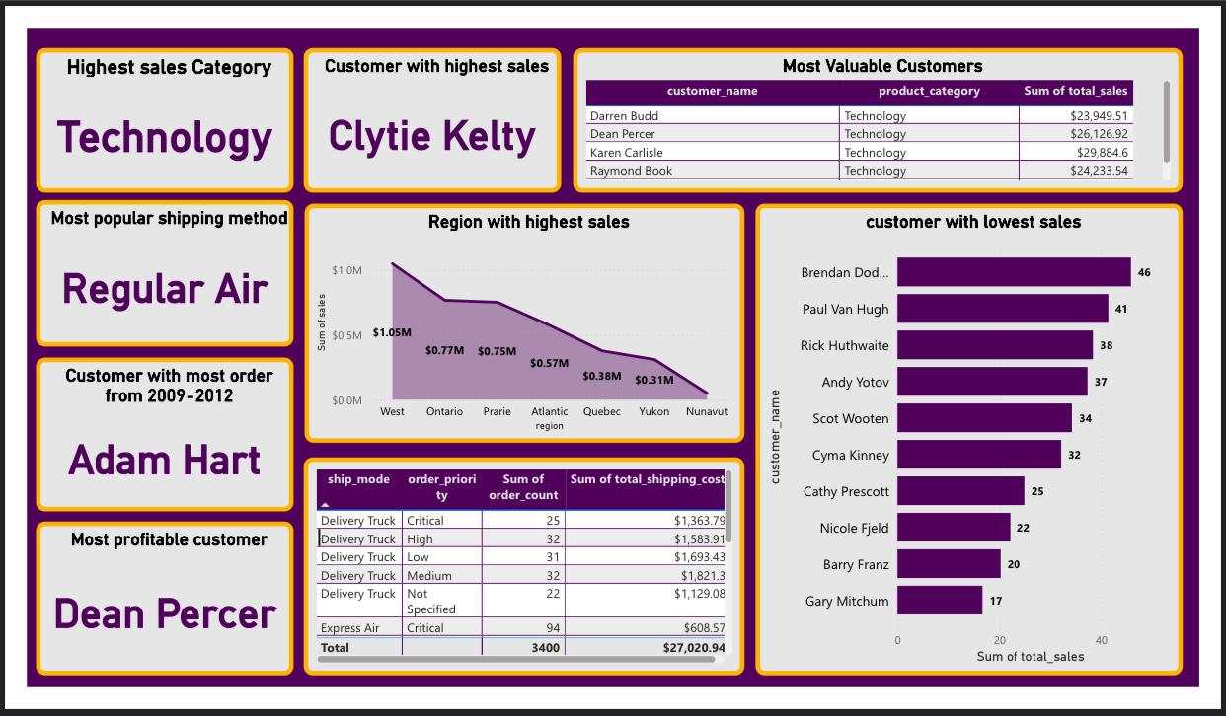

## **5. Recommendations**

Based on the analysis, we recommend the following actions:

* **Investigate High-Return Product Categories**: Conduct quality checks on Technology to identify reasons for high returns.
* **Target Customer Segments**: Offer targeted promotions or support to Cray Mitchum, Barry Franz, Nicole Fjeld, Cathay, Prescott, Cyma Kinney Scot Wooten to improve satisfaction and reduce returns.
* **Optimize Shipping Processes**: Review Delivery Truck logistics to address potential issues causing returns.
* **Regional Focus**: Implement customer feedback surveys in West, Ontario, Prairie, Atlantic Region, Quebec, Yukon, Nunavut to understand regional return drivers.

Questions

1. Which product category had the highest sales?

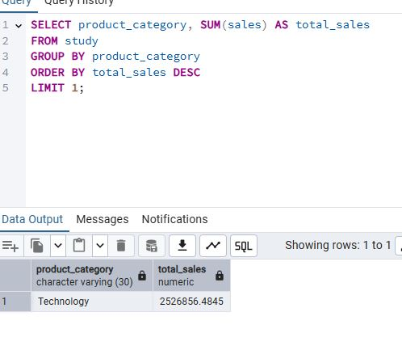

1. What are the Top 3 and Bottom 3 regions in terms of sales?

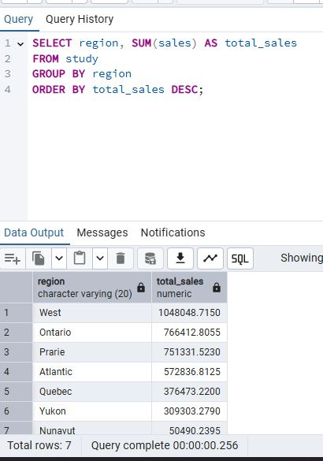

1. What were the total sales of appliances in Ontario?

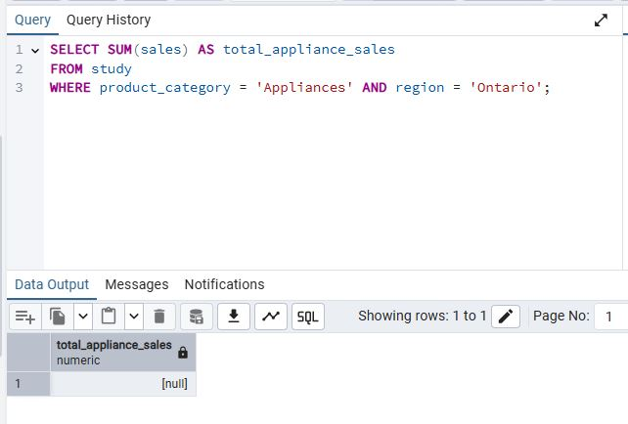

1. Advise the management of KMS on what to do to increase the revenue from the bottom 10 customers.

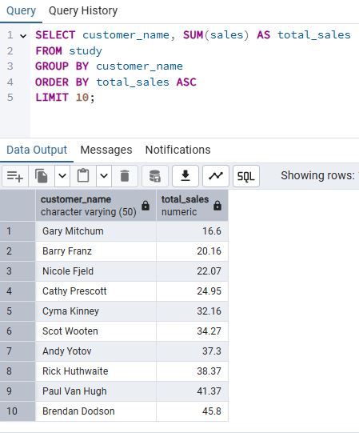

1. KMS incurred the most shipping cost using which shipping method?

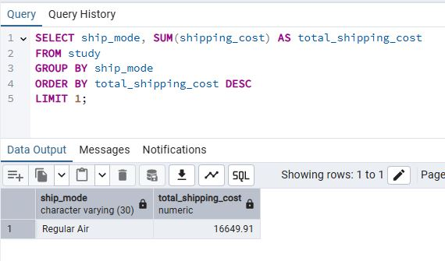

1. Who are the most valuable customers, and what products or services do they typically purchase?

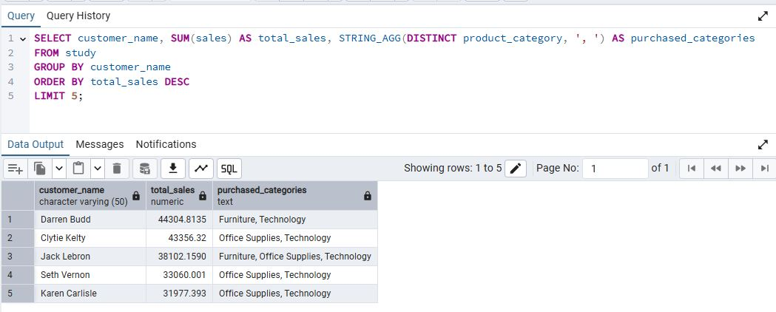

1. Which small business customer had the highest sales?

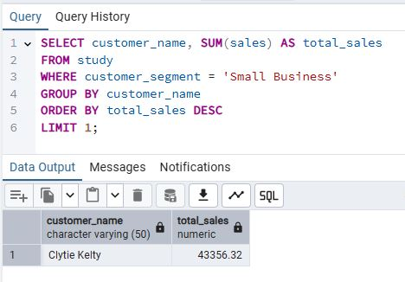

1. Which Corporate Customer placed the most number of orders in 2009–2012?

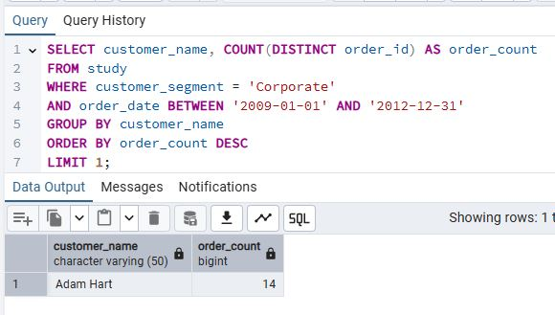

1. Which consumer customer was the most profitable one?

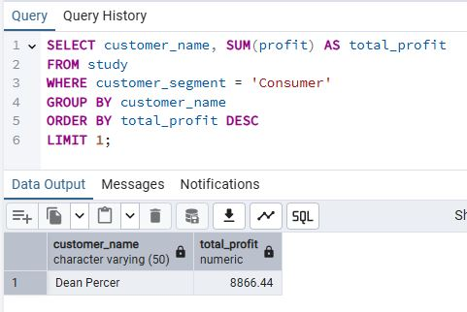

1. Which customer returned items, and what segment do they belong to?

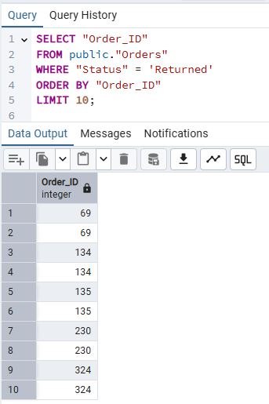

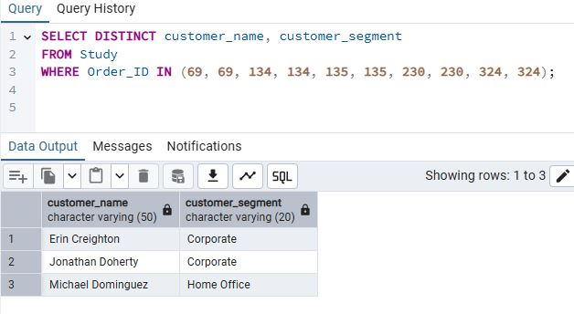

1. If the delivery truck is the most economical but the slowest shipping method and Express Air is the fastest but the most expensive one, do you think the company appropriately spent shipping costs based on the Order Priority? Explain your answer.

